#### Cardiologic examination report

|  |  |
| --- | --- |
| καρτα2 | **Date: {{ date }}**  **---**  **Mr./Ms. {{ owner }}**  **« {{ petName }} »**  {{ breed }}  {{ sex }}, {{weight }} kg  Age: {{age}} |

**Dr. Theodoros SINANIS**

DVM, MSc, MRCVS

*Master of Science in Veterinary Internal Medicine,*

*Specially trained in Veterinary Cardiology at the*

*Cardiology Unit of Alfort,Paris- France*

*(École Nationale Vétérinaire d'Alfort)*

*European Society of Veterinary Cardiology member*

** Medical history – clinical examination**

**History :**

* Referring physician:**{% if referVet %} {{referVet}}{% else %} -{% endif %}.**
* Cardiologic examination in account of previous murmur auscultation, during routine clinical examination. {% if historic %}{% for moment in historic %}
* {{ moment }}{% endfor %}
* {% endif %}Radiographic examination: {{radiologicalChestAnalysis}}
* Cardiac medication so far: {% if medication %}{% for med in medication %} **{{med.medicationEngMenu}}** ({{med.doseNumber}} {{med.unitOfMeasurementMenu}} {{med.doseMenu}}),{% endfor %}{% else %} **None**{% endif %}**.**

**Clinical findings** :

* {% if rythm %}{{rythm}}{% else %}{% endif %}{% if auditoryFindings %}Cardiac auscultation revealed a {{auditoryFindings.systolicEngMenu}}, {{auditoryFindings.degreeEngMenu}}, {{auditoryFindings.auscultationEngMenu}} murmur, with a PMI at the {{auditoryFindings.auditoryEngMenu}}, {{auditoryFindings.heartEngMenu}} at the {{auditoryFindings.valveEngMenu}}. {% else %}
* Cardiac auscultation revealed a holosystolic, 4th degree (4/6) regurgitant murmur, with a PMI at the left apex of the heart, at the mitral valve area. {% endif %}
* {{auditoryLung}}
* {{cough}}
* {{heartRate}}
* {% if mucous %}{% if mucous**==**’ND.’ %}Mucous membranes: {{mucous}} {% else %}{{mucous}}{% endif %}{% endif %}
* {% if dental %}{% if dental **==**’ND.’ %}Dental calculus: {{dental}}{% else %}{{dental}}{% endif %}{% endif %}
* {{bodyWeight}}.
* {{lymph}}

 **Echocardiography exam results**

The examination was performed with cardiac single crystal phased array probes (P 2-9 & P 1-5 mHz).

{% if PDF %}

|  |  |  |  |
| --- | --- | --- | --- |
| **Παράμετροι** |  | **Παράμετροι** |  |
| RVDd | {% if PDF.RVDd %}{{PDF.RVDd}}{% else %}4.3{% endif %} mm | Ao Vmax | Vmax = {% if PDF.AoVmax %}{{PDF.AoVmax}}{% else %}1.15{% endif %} m/s |
| IVSd | {% if PDF.IVSd %}{{PDF.IVSd}}{% else %}6{% endif %} mm | P Vmax | Vmax = {% if PDF.PVmax %}{{PDF.PVmax}}{% else %}0.79{% endif %} m/s |
| LVDd | {% if PDF.LVDd %}{{PDF.LVDd}}{% else %}43.9{% endif %} mm | Ant. mitral leaflet | 3.9 mm |
| PWd | {% if PDF.PWd %}{{PDF.PWd}}{% else %}6.7{% endif %} mm | Post. mitral leaflet | 3.5 mm |
| IVSs | {% if PDF.IVSs %}{{PDF.IVSs}}{% else %}22{% endif %} mm | Mitral E/A wave | {% if PDF.MitralE %}{{PDF.MitralE}}{% else %}1.38{% endif %}/{% if PDF.Awave %}{{PDF.Awave}}{% else %}0.46{% endif %} ({% if PDF.MVEA %}{{PDF.MVEA}}{% else %}2.98{% endif %}) |
| LVDs | {% if PDF.LVDs %}{{PDF.LVDs}}{% else %}12.6{% endif %} mm | DT | {% if PDF.DT %}{{PDF.DT}}{% else %}64{% endif %} ms |
| PWs | {% if PDF.PWs %}{{PDF.PWs}}{% else %}11.9{% endif %} mm | RA/LA | 0,9 |
| FS | {% if PDF.FS %}{{PDF.FS}}{% else %}50{% endif %} % | Mit. reg. Vmax | {% if PDF.MRVmax %}{{PDF.MRVmax}}{% else %}-{% endif %} m/s |
| LA- Ao | {% if PDF.LA %}{{PDF.LA}}{% else %}35{% endif %}-{% if PDF.Ao %}{{PDF.Ao}}{% else %}13.6{% endif %} mm | Tric. reg. Vmax | {% if PDF.TRVmax %}{{PDF.TRVmax}}{% else %}-{% endif %} m/s |
| LA/Ao | {% if PDF.LAAo %}{{PDF.LAAo}}{% else %}2.5{% endif %} | PT/Ao | 1 |

{% else %}

|  |  |  |  |
| --- | --- | --- | --- |
| **Parameters** |  | **Parameters** |  |
| RVDd | 4.3 mm | Ao Vmax | Vmax = 1.15 m/s |
| IVSd | 6 mm | P Vmax | Vmax = 0.79 m/s |
| LVDd | 43.9 mm | Ant. mitral leaflet | 3.9 mm |
| PWd | 6.7 mm | Post. mitral leaflet | 3.5 mm |
| IVSs | 11.3 mm | Mitral E/A wave | 1.38/0.46 (2.98) |
| LVDs | 22 mm | DT | 64 ms |
| PWs | 11.9 mm | RA/LA | 0.9 |
| FS | 50 % | Mit. reg. Vmax | - m/s |
| LA- Ao | 35-13.6 mm | Tric. reg. Vmax | - m/s |
| LA/Ao | 2.5 | PT/Ao | 1 |

{% endif %}

## Interpretation

Περιγραφή: Περιγραφή: ac387 **Right parasternal and transventricular short-axis view (m-mode):**

* Increased end-diastolic & normal end-systolic LV dimensions.
* The contractility of the LV is WNL.
* Normal right ventricular dimensions.

Περιγραφή: Περιγραφή: ac387 **Left atrium examination presents:**

* The left atrial dimensions are increased at the end-systole (LA/Ao = 2.5 >1.6).
* Significant regurgitant volume (~295mm2; 7.9ml) through the mitral valve to the left atrium is present on colour flow Doppler examination.

Περιγραφή: ac387 **Right parasternal and transaortic short-axis view:**

* No anatomic lesions were found at the level of the pulmonary annulus.
* Normal pulmonic flow.
* No pulmonic regurgitation is present.

Περιγραφή: ac387 **Right parasternal long-axis four & five chamber views:**

* Mitral valve (anterior leaflet) shows severe thickening and moderate prolapse, compatible with degenerative lessions.
* Normal right atrial dimensions.
* Decreased right to left atrial ratio.
* No aortic regurgitation is present.
* No interventricular nor interatrial septal defect was found.

Περιγραφή: ac387 **Left parasternal long-axis four & five chamber views:**

* Luminar aortic flow at the level of the aortic annulus.
* Increased E transmitral peak flow velocity.
* No tricuspid regurgitation is present on colour-flow Doppler.

Περιγραφή: Περιγραφή: ac387 **Other points:**

* No pericardial nor pleural effusion is present.
* No pulmonary hypertension is present.
* {% if ecg %}{{egc}}{% else %} Sinus rhythm{% endif %} with a few supraventricular premature complexes during the examination. Heart rate: 128-138 bpm.

### Conclusions

* **Degenerative mitral valve disease** of 3rd echocardiographic stage (**3/5**); **{{clinicalStage}}** clinical stage (*ACVIM Consensus 2019*), {{hypertension}}{% if PG %} (PG: {{PG}} mmHg){% else %}{% endif %}{% if AddOn %} and {{AddOn}}{% else %}{% endif %}.
* Mitral valve disease (endocardiosis) appears frequently in aged, small sized dogs and is characterised by relatively slow development and degeneration of one or both mitral leaflets, with or without valve prolapse.
* DMVD is not a curable disease but clinical stabilisation and clinical signs control is most of the time achieved with specific medication.
* A 2nd echocardiographic examination is recommended after {% if checkUp %}{% for che, months, years in checkUp %}{{che}} months (**{{months}} {{years}}**) {% endfor %}{% else %}6-8 months(**July - September 2022**){% endif %}.

{% if medication2 %}

* Cardiac medication: {% for med2 in medication2 %}

1. **{{med2.medication2EngMenu}}** ({{med2.doseNumber}} {{med2.unitOfMeasurementMenu}} {{med2.doseMenu}}) {% endfor %}{% else%}

* Cardiac medication: **not recommended.**

{% endif %}

**Yours sincerely:**

**Dr. Theodoros Sinanis**

**Δρ. Θεόδωρος Σινάνης**

[theodsin@hotmail.com](mailto:theodsin@hotmail.com)

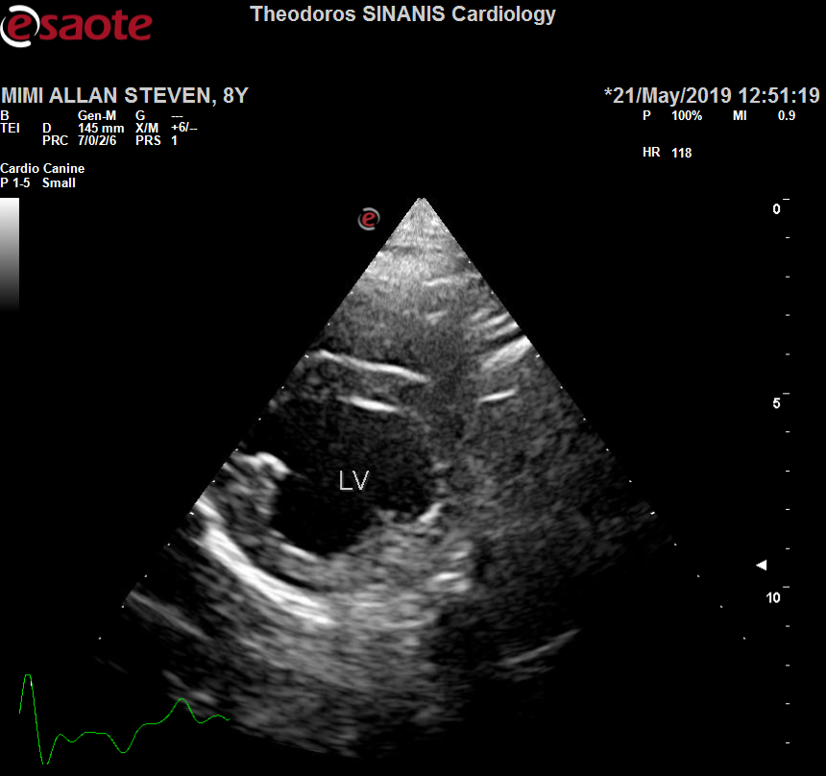 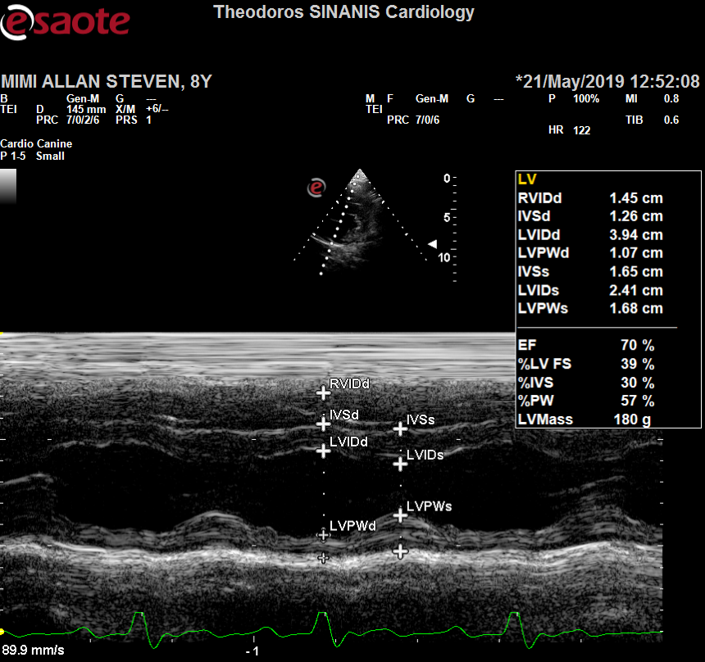

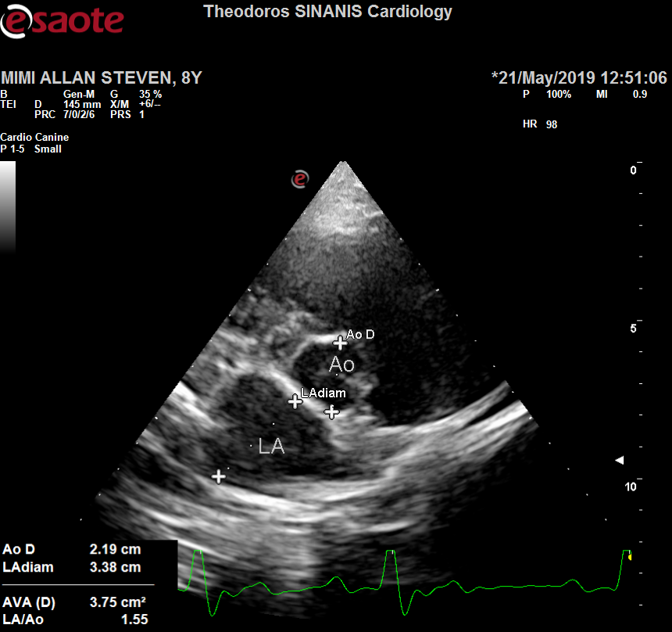 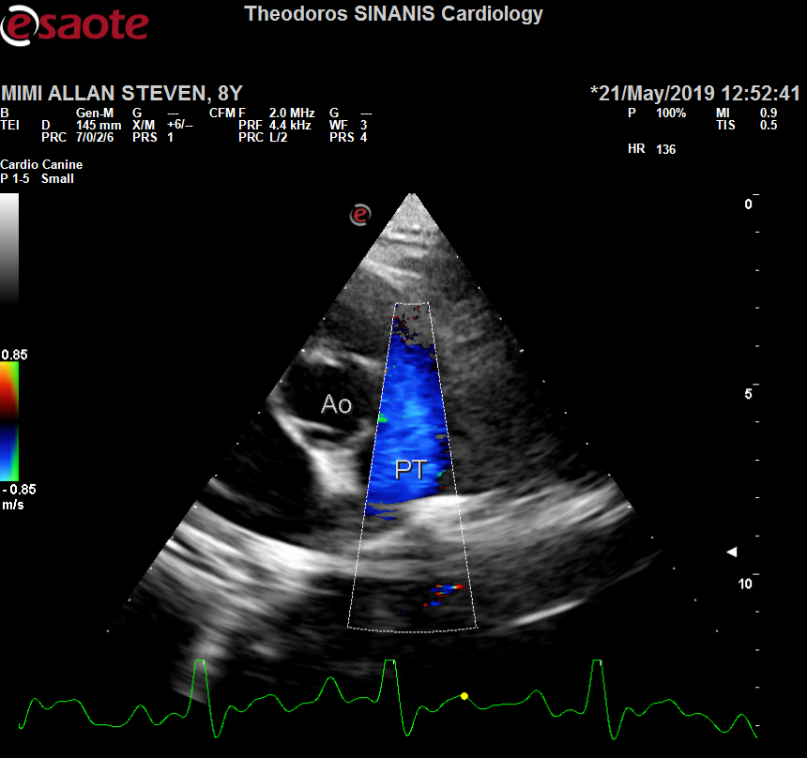

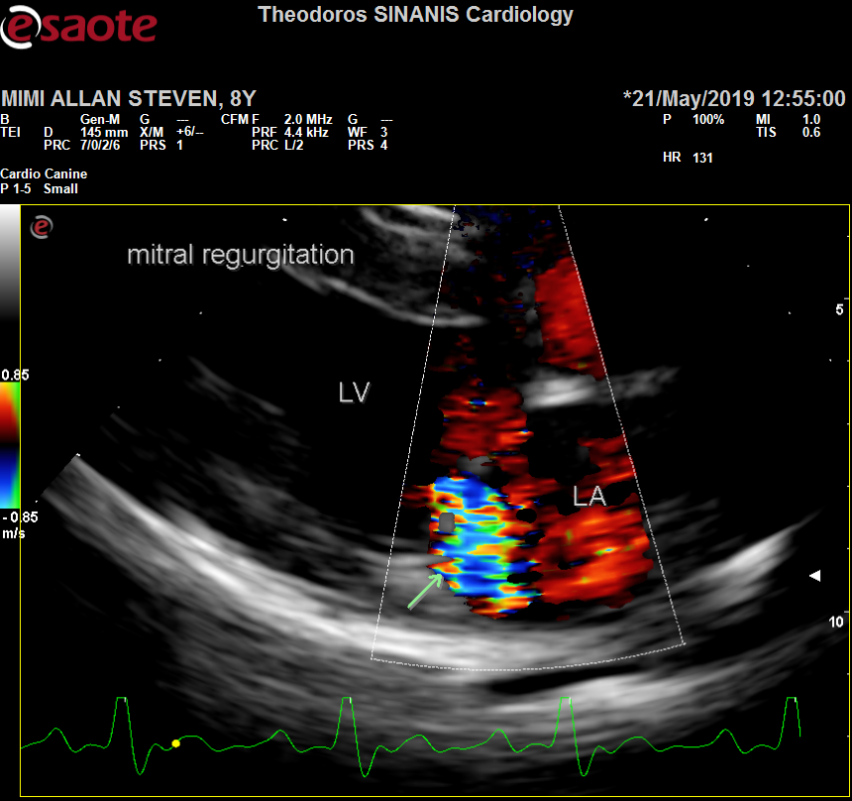 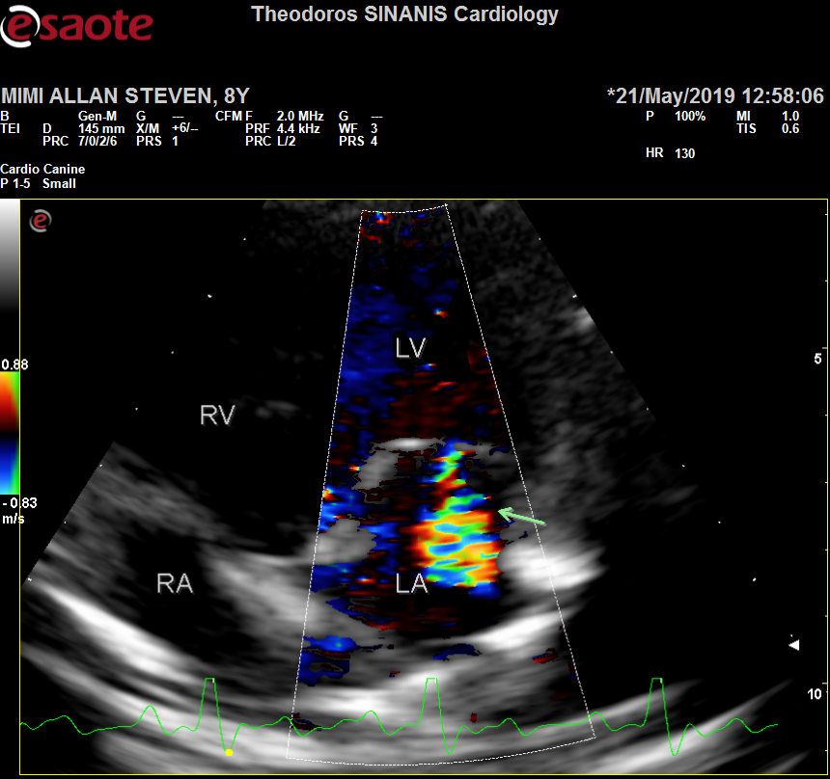

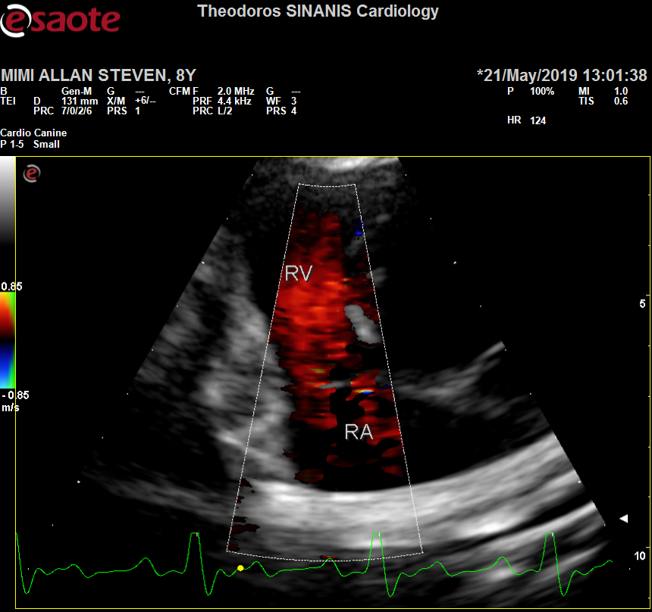 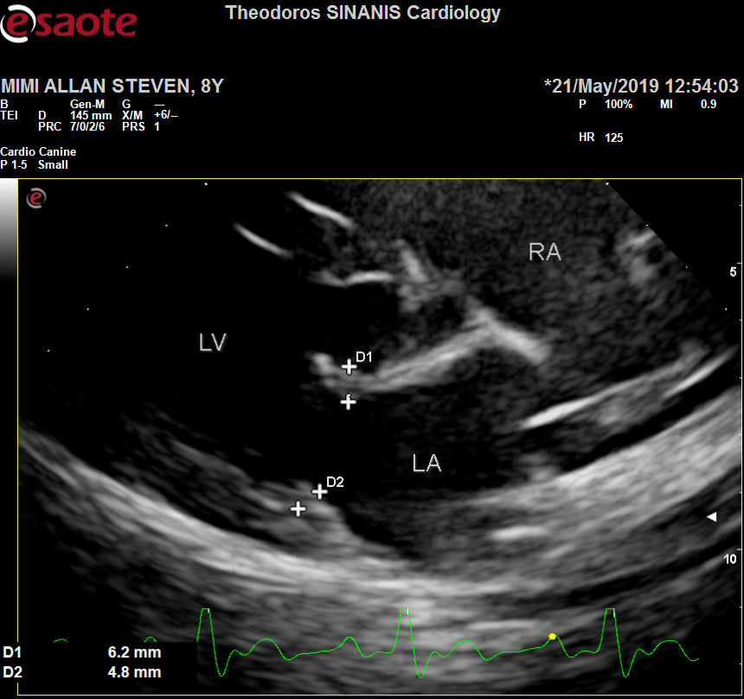

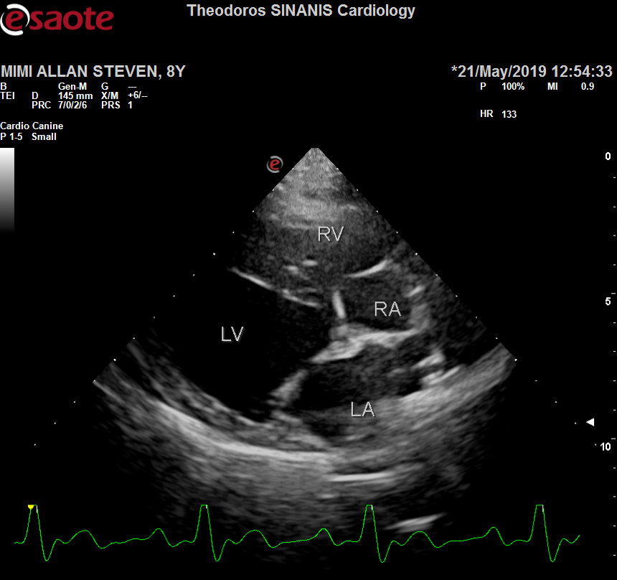 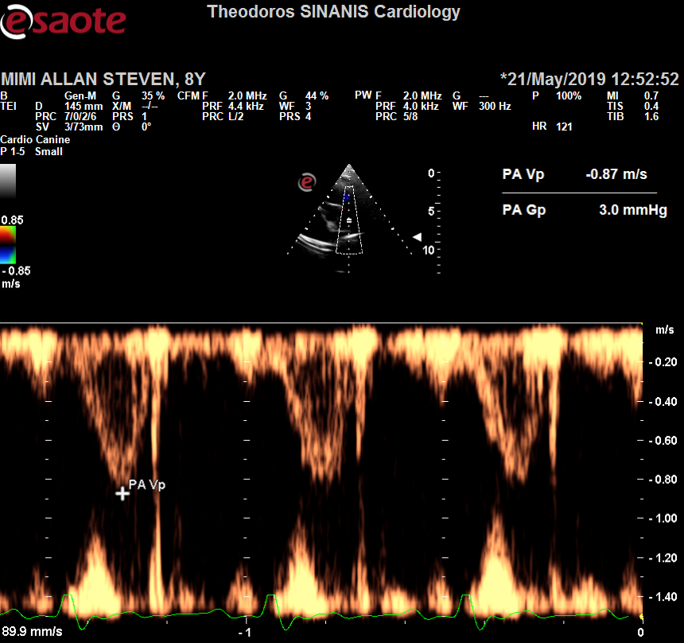

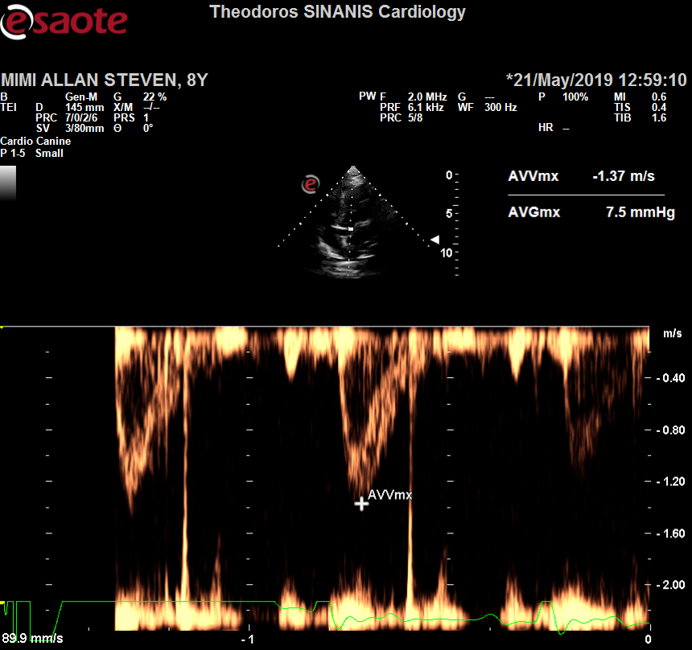 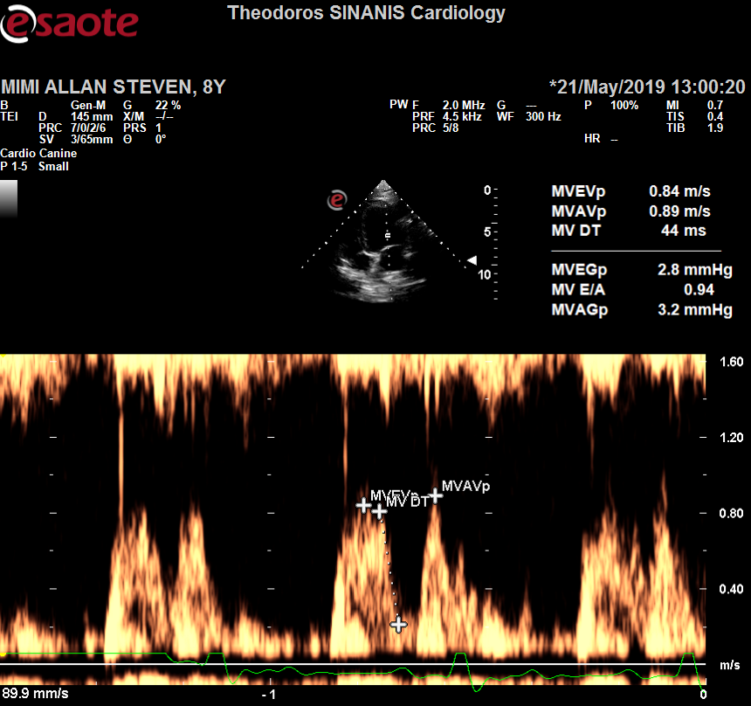Description: Περιγραφή: Περιγραφή: ac387

Περιγραφή: Περιγραφή: ac387